FLAT RIVER WC & ROB WALLER’S

ALL AMERICAN WRESTLING CAMPS
LOWELL, MICHIGAN

TECHNIQUE – INTENSE DRILLING – LIVE WRESTLING
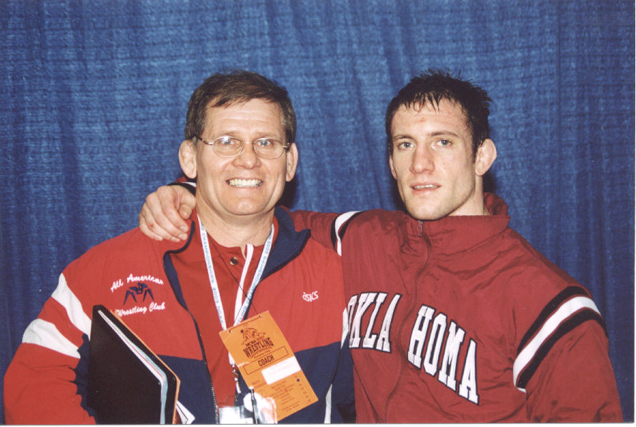
July 25th thru July 29th 2011

ALL AGES & SKILL LEVEL WELCOME
Accepting 40 Wrestlers
Cherry Creek School 12675 Foreman St. Lowell, Michigan
Pennsylvania – Michigan – Ohio - West Virginia - Indiana – California - Illinois

Head Coach of the Pennsylvania All-American WC, Rob Waller will bring his Staff of Clinicians to Lowell, Michigan. The main emphasis of this Camp will be teaching proper technique for Championship style wrestling. Instruction on multiple setups for double and single leg takedowns Bottom work to include, stand-ups, reversals, escape from leg rides. Top work to include tilts, turns, & legs, an excellent cradle series and fundamental breakdowns. This is a commuter Camp; wrestlers must bring their own lunch,

Training Sessions & Schedule will be followed:
7/25 Monday Morning - Camp Check-In 8:30 - 9:00
Monday 9:30 – 11:30 / 12:30 – 3:00
7/26 Tuesday: 9:30 – 11:30 pm / 12:30 – 3:00
7/27 Wednesday: 9:30 – 11:30 am / 12:30 – 3:00 (Match Night Wednesday Evening - Lowell Duals Camp)
7/28 Thursday: 9:30 – 11:30 am / 12:30 – 3:00
7/29 Friday: 9:30 – 11:30 am (Weigh-In for Midnight Madness Friday evening Tournament at Lowell)

Wrestlers planning to attend the Friday July 29th Midnight Madness Tournament at Lowell must mail Tournament form and make payment to Creative Wrestling (Separate from Camp Entry Fee)
Midnight Madness Tournament Form at: www.grandriverrumble.com

Camp Fee: $150 Commuters ~ $275 Overnight – Mail Deposit or Camp Fee Payable to: Rob Waller
Mail to: R. Stehley 2901 Parnell Ne Ada, MI 49301 No refunds after the first day of Camp.
Limited Overnight Campers will be accepted $275 includes all meals & camp activities.

Wrestler’s Name ___________________________ Age______ Grade______

Address___________________________ City____________________ State______

School/Club_____________________________ Phone #___________________ E-Mail __________________

Emergency Contact and Phone ________________________________

